- MATCH THE SPORTSMAN WITH HIS HOME COUNTRY
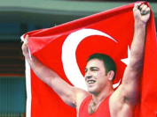 Hamza Yerlikaya GREECE
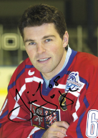 Jaromír Jágr ESTONIA
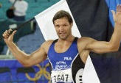 Erki Nool TURKEY
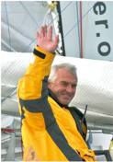 Yves Parlier CZECH REPUBLIC
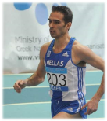 Chistoforos Merousis POLAND
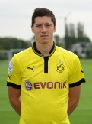 Robert Lewandowski FRANCE
- TRUE OR FALSE?
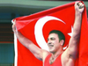 Hamza Yerlikaya is a football player 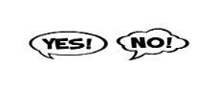
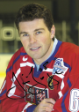 Jaromír Jágr is an ice hockey player
Erki Nool is an decathlete
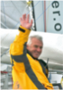 Yves Parlier is a sailor
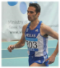 Chistoforos Merousis is a runner
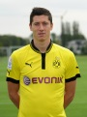 Robert Lewandowski is a Greco - Roman Style wrestler
- FIND THE RIGHT ANSWER
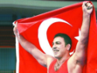 Hamza Yerlikaya a) The only Turkish wrestler to become European Champion eight times
b) The only Greek wrestler to become European Champion eight times
c) The only Greek runner to become European Champion eight times
Jaromír Jágr a) began skating at the age of two, and he
immediately showed exceptional abilities
b) began skating at the age of three, and he
immediately showed exceptional abilities
c) began skating at the age of five, and he
immediately showed exceptional abilities
Erki Nool a) is an Estonian decathlete and singer
- is an Estonian decathlete and journalist
c) is an Estonian decathlete and politician
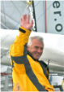 Yves Parlier a) took part in 3rd Vendée Globe one man sailing race around the world without pets
b) took part in 3rd Vendée Globe one man sailing race around the world without call
c) took part in 3rd Vendée Globe one man mailing race around the world without call
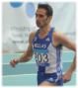 Chistoforos Merousis a) was born in Istanbul in March,1982
b) was born in Chios in March,1982
c) was born in Chios in March,1992
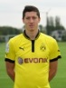 Robert Lewandowski a) a captain of the Polish national football team
- a captain of the Polish national judo team
c) a captain of the Polish national American football tea

